Evidence Questions(2) on JavaScript
IDB-BISEW IT Scholarship Project
Batch ID: WDPF/TCLD-A/47/01
Instructor Name: Syed Ziaul Habib

- Create an html document to find Prime of a given number (n!) where the number is taken from user.
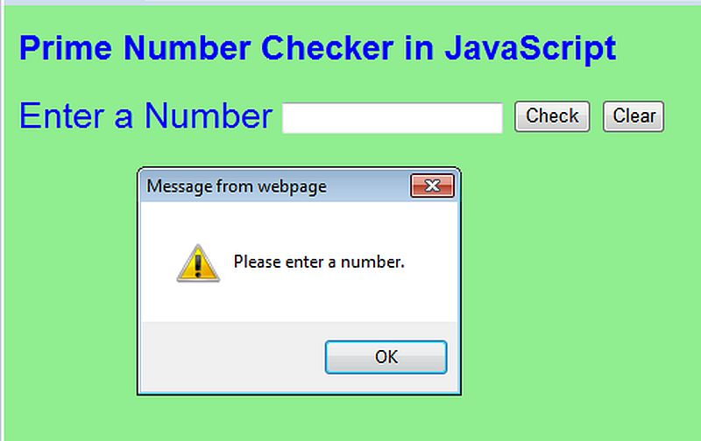

- Create a login form and check the following validation using JavaScript:
- Email address with valid structure.
- Password is minimum 6 characters long.
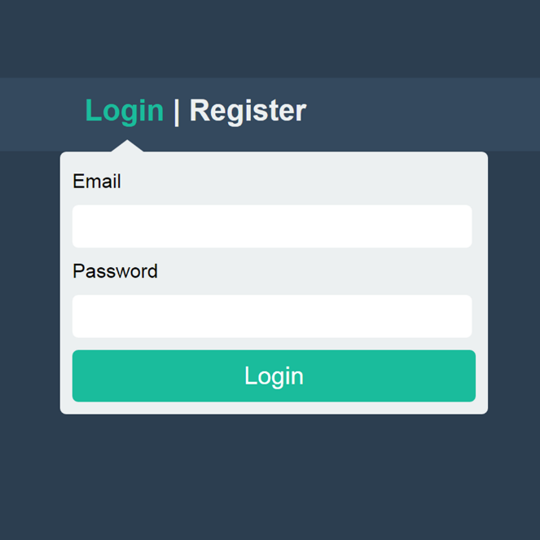

- Create an html document with a student entry form. All fields are must be filled out. Apply JavaScript validation for each field. After validation preview them in a new window.
